## Topic 4 Tutorial

## Using Oracle Data Modeler answer the following:

**Q1. For the case-study design of Company, design the full (Advance) E-R diagram that shows the link between them and list all the attributes along with PK and FK using oracle data modeler.**

* COMPANY
  + Employees, departments, and projects
  + Company is organized into departments
  + Department controls a number of projects
  + Employee: store each employee’s name, Social Security number, address, salary, sex (gender), and birth date
  + Keep track of the dependents of each employee

1. Which normal form (Normalization) do the attributes in these entities belong to ?

It is designed in the third normal form. Every entity is transitively or directly dependent on the other entities.

1. What will be the 0NF attributes of this system ?

There is no normalization of data. Everything is scattered and unstructured.

1. Draw a simple USE Case for the above system using [www.draw.io](http://www.draw.io)

**Once you have completed the above task, please create and Oracle Apex account using the instructions below :**

**APEX Set up for Hands-on-Labs**

The series of hands-on labs are designed to teach you how to build applications using Application Express. The primary vehicle for teaching is a single-use case which is expanded on with each lab.

To run these hands-on-labs, you need to:

Obtain an Oracle Application Express Workspace and a Workspace Administrator /Developer user account.

**Oracle Cloud Free Tier** – <https://apex.oracle.com/en/> -Sign up for Always Free Oracle Cloud, provision an Autonomous Database, and create an APEX workspace.

**Setting up Oracle Application Express (APEX) Account**

The Oracle APEX Application Development service provides a preconfigured, fully managed, and secured environment in Oracle Cloud to build and deploy world-class applications.

Go to the APEX web page

<https://apex.oracle.com/en/>

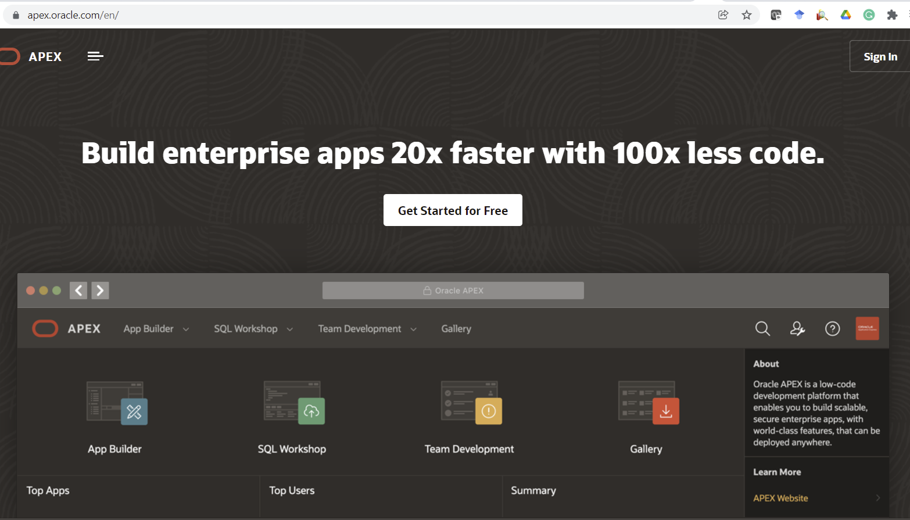

**Request a free APEX workspace using**

The Oracle APEX Application Development service provides a preconfigured, fully managed, and secured environment in Oracle Cloud to build and deploy world-class applications.

Click on the free Apex workspace

Follow the on-screen instructions to create an account and you will get an instant email.

**NOTE:** Please save your username, Password and unique workspace for the next time to login

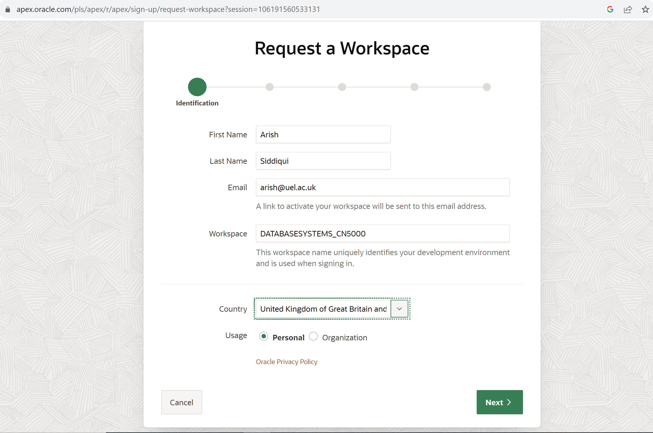

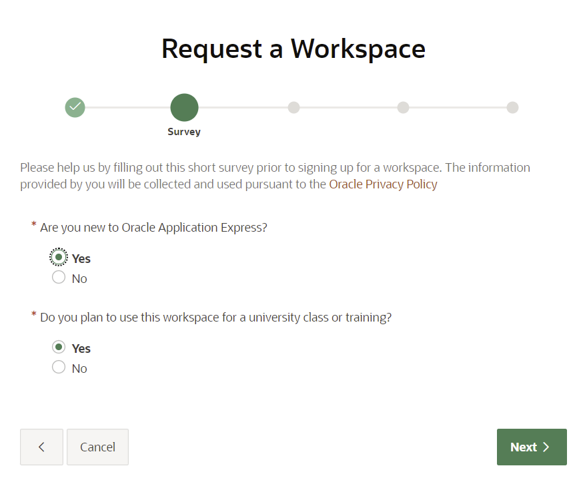

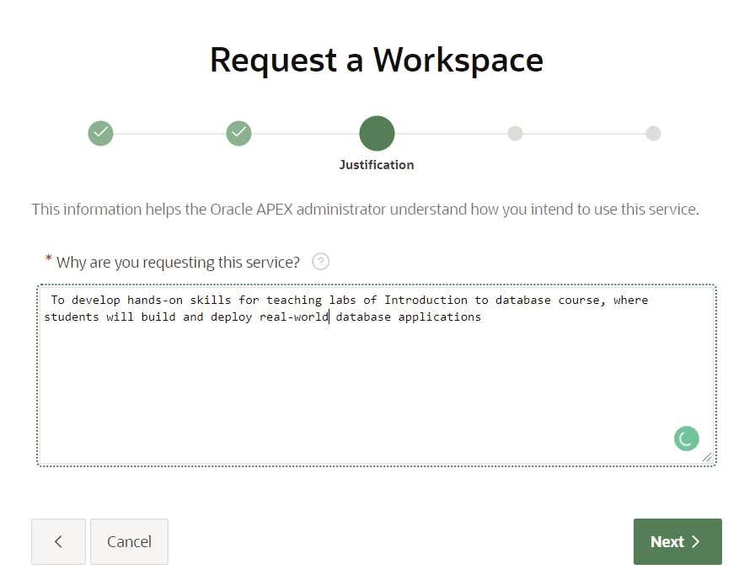

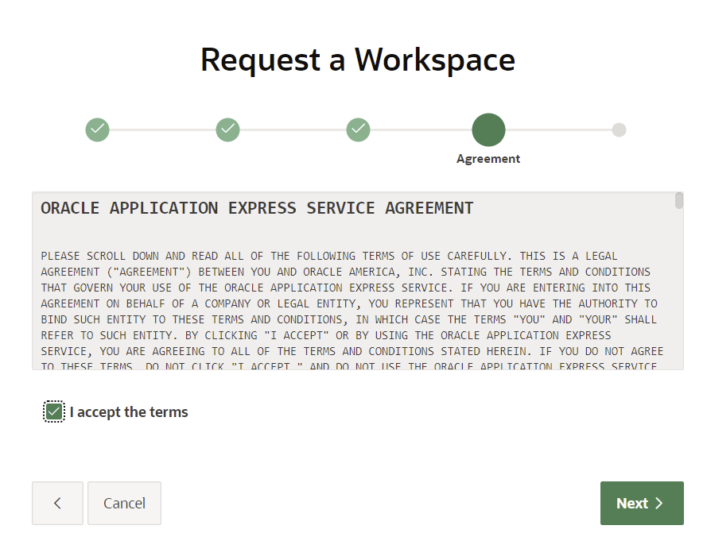

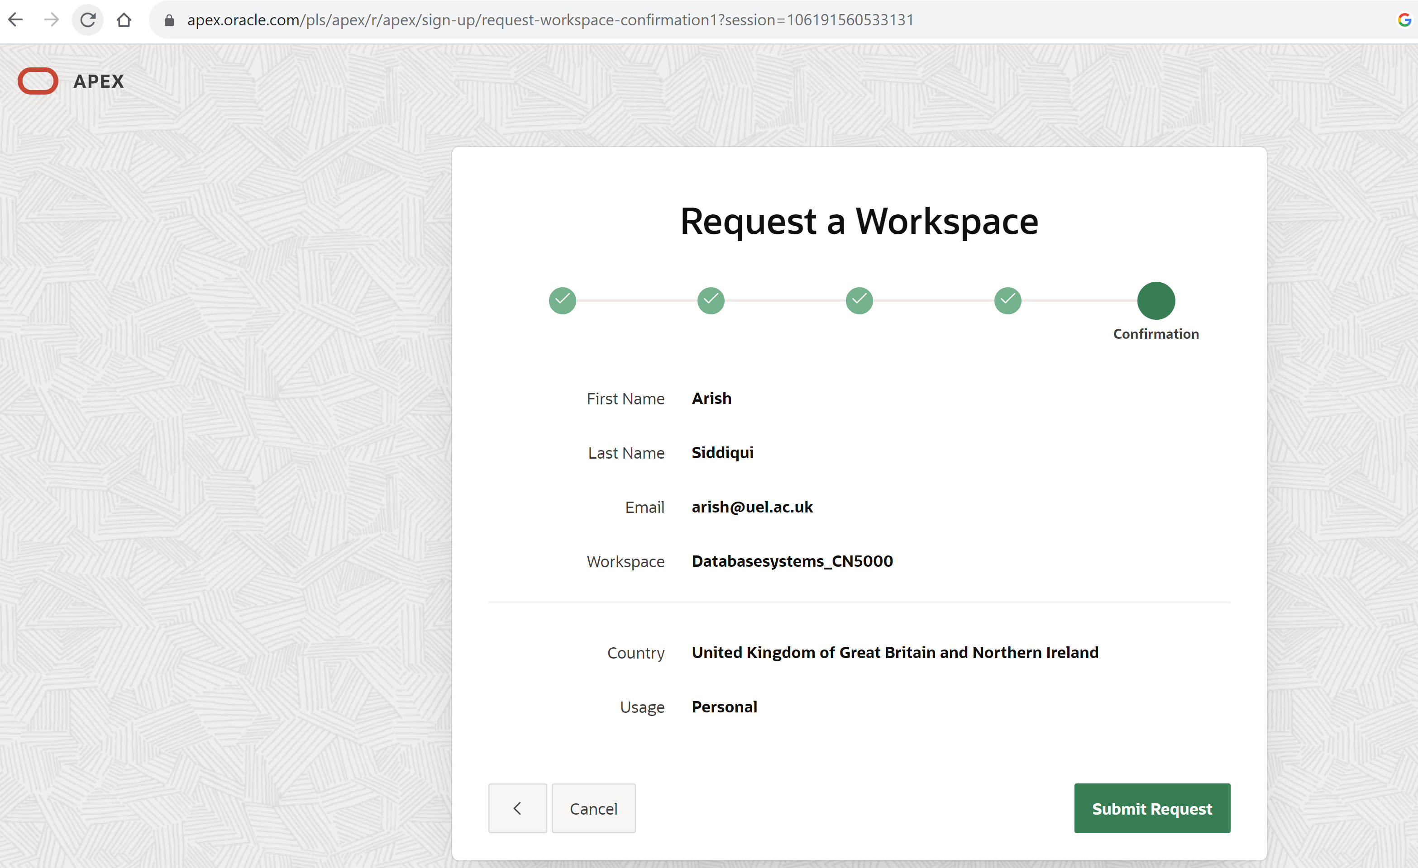

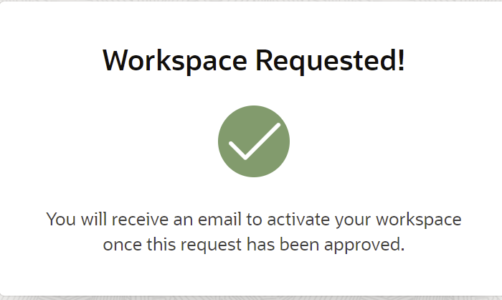

Check you email and click on Create Workspace

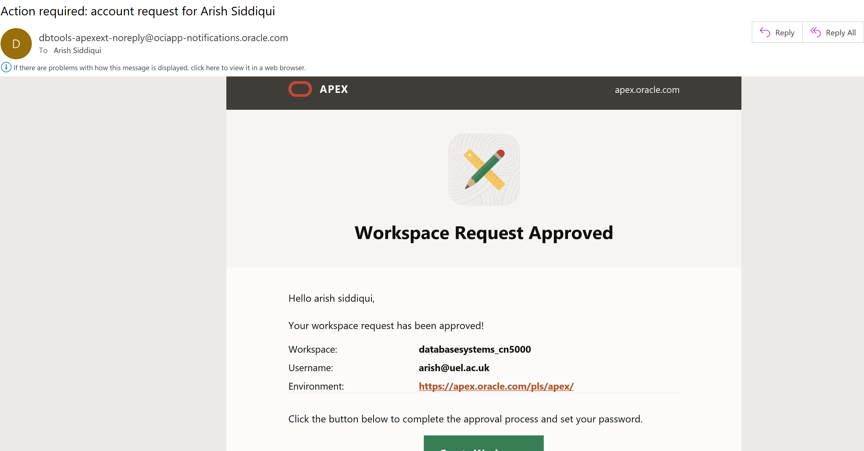

**Note down workspace and username for later login and click on Create Workspace.**

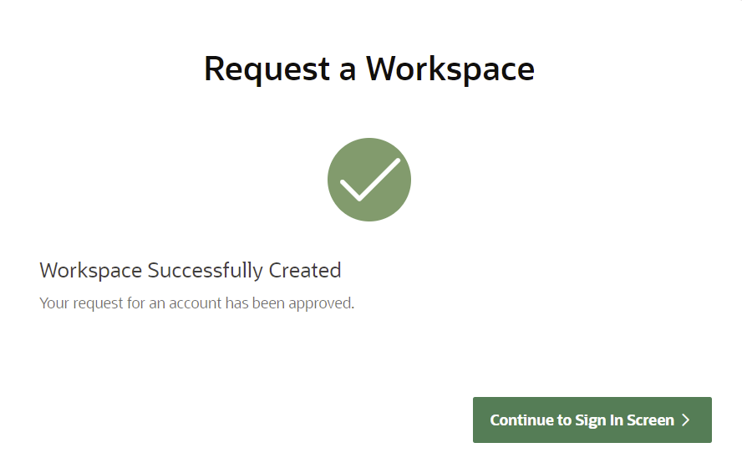

Click on Continue to Sign In Screen and set your first time password, then click on Change Password.

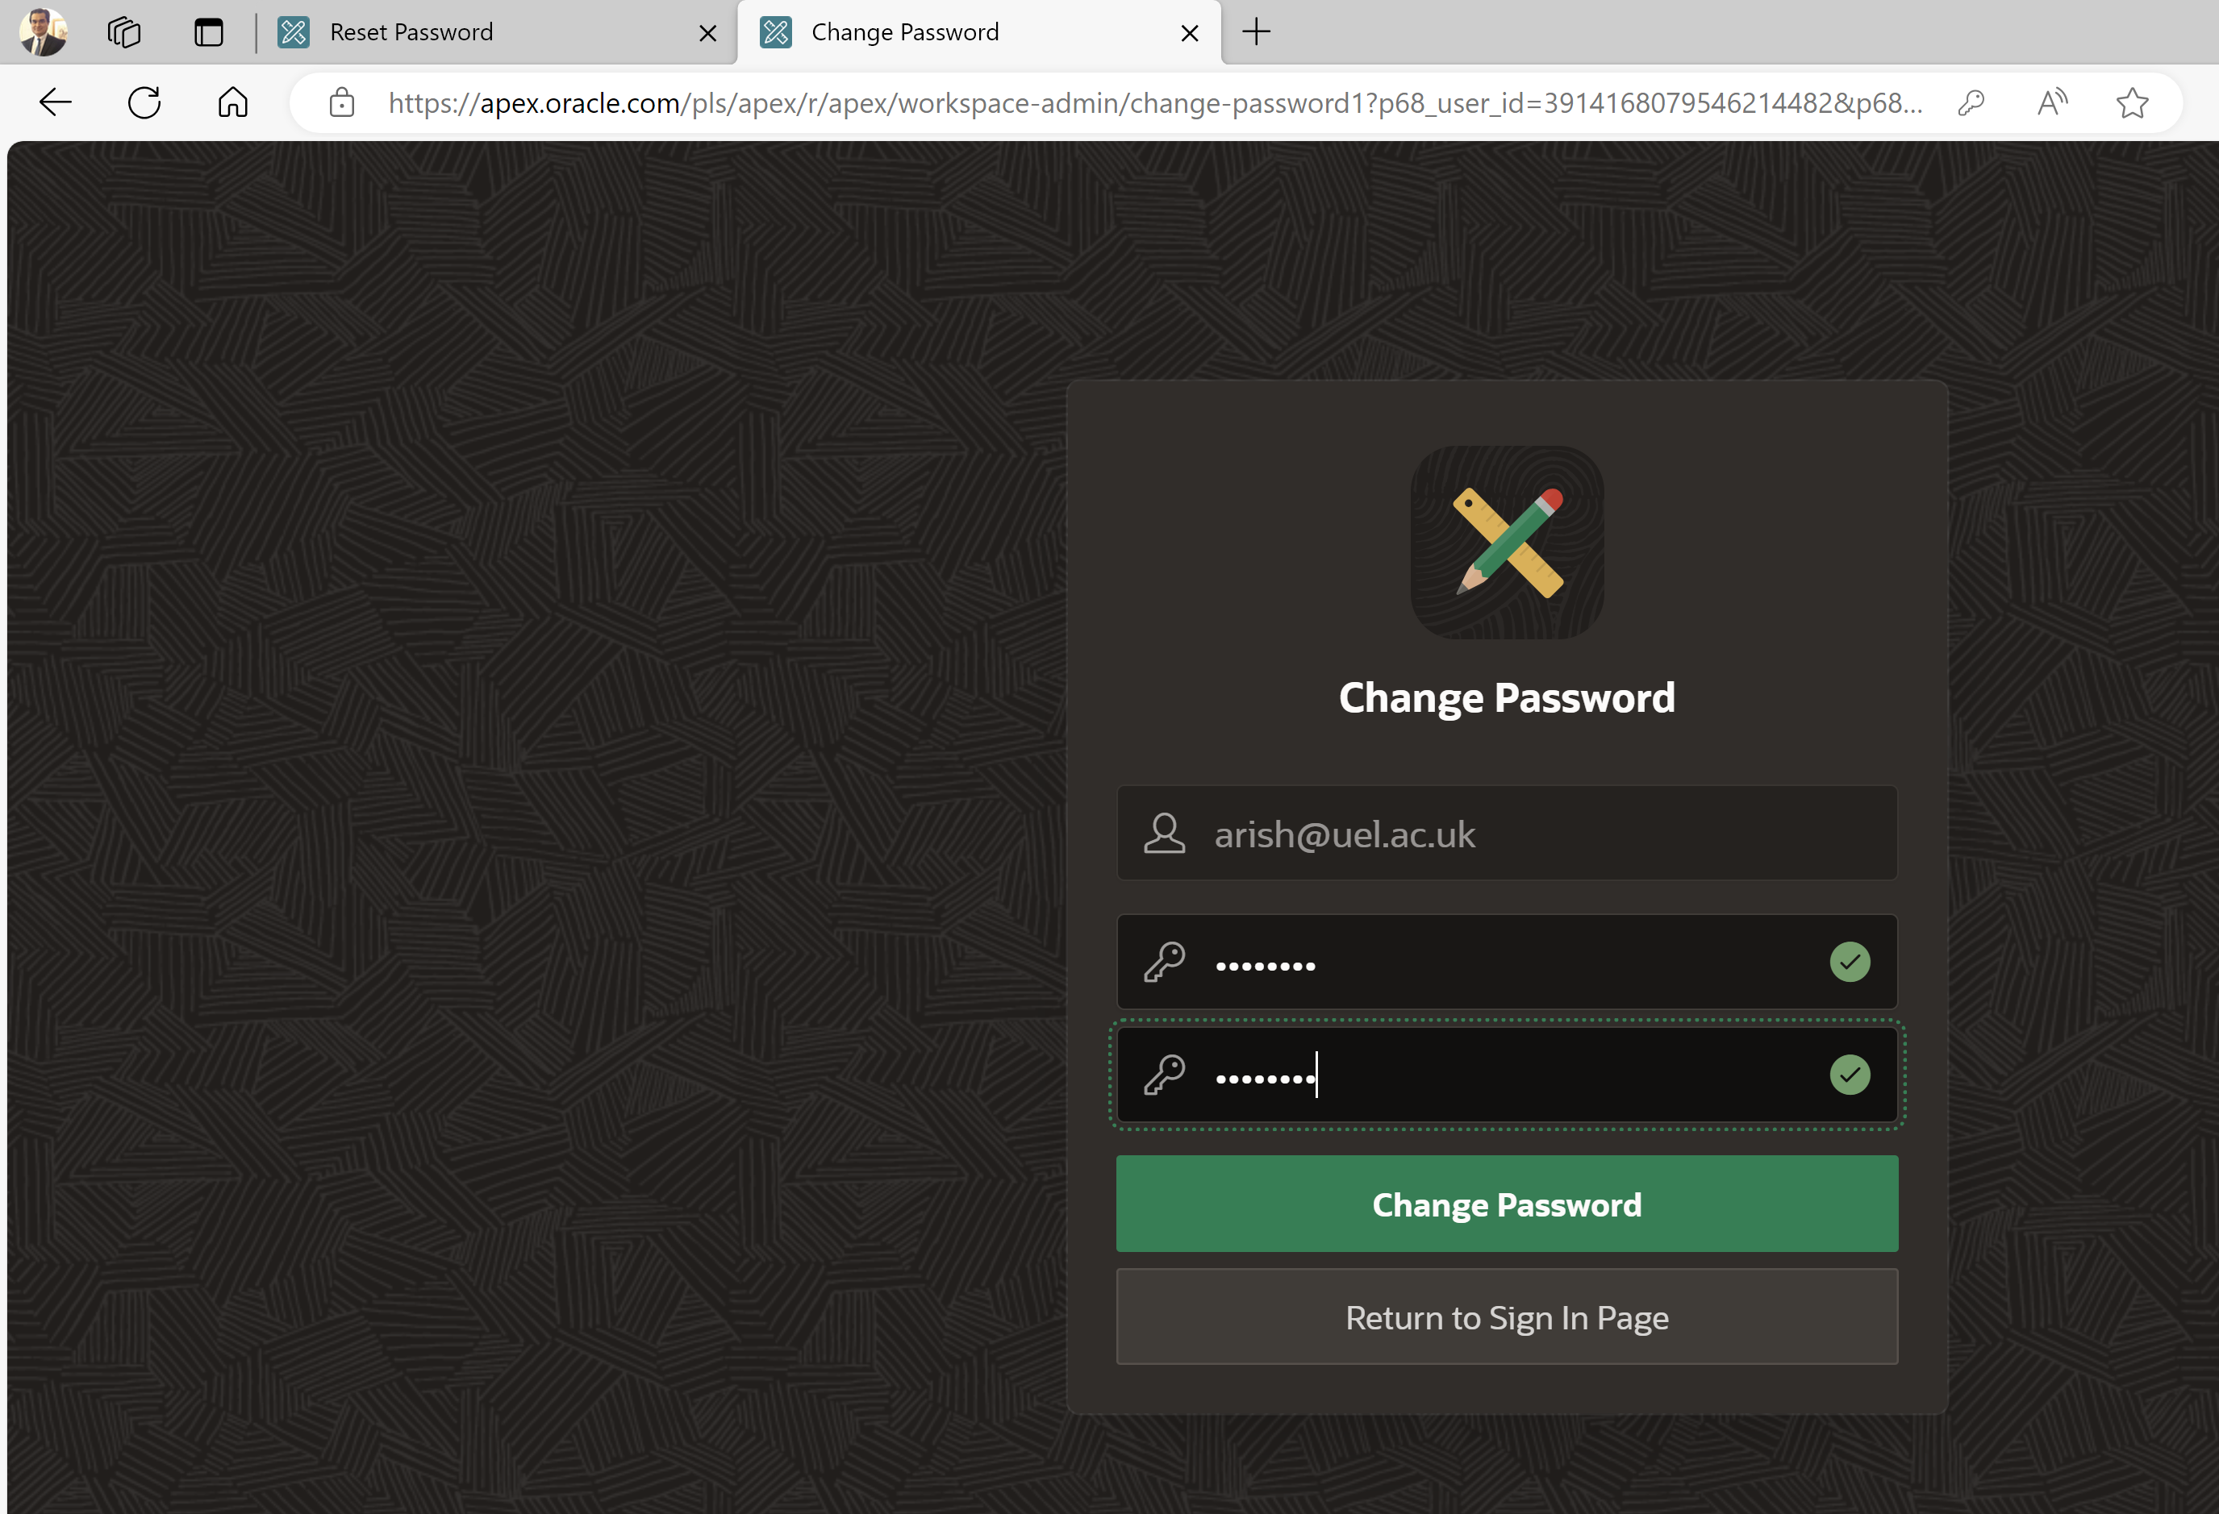

**Must save your password for the next time Login**

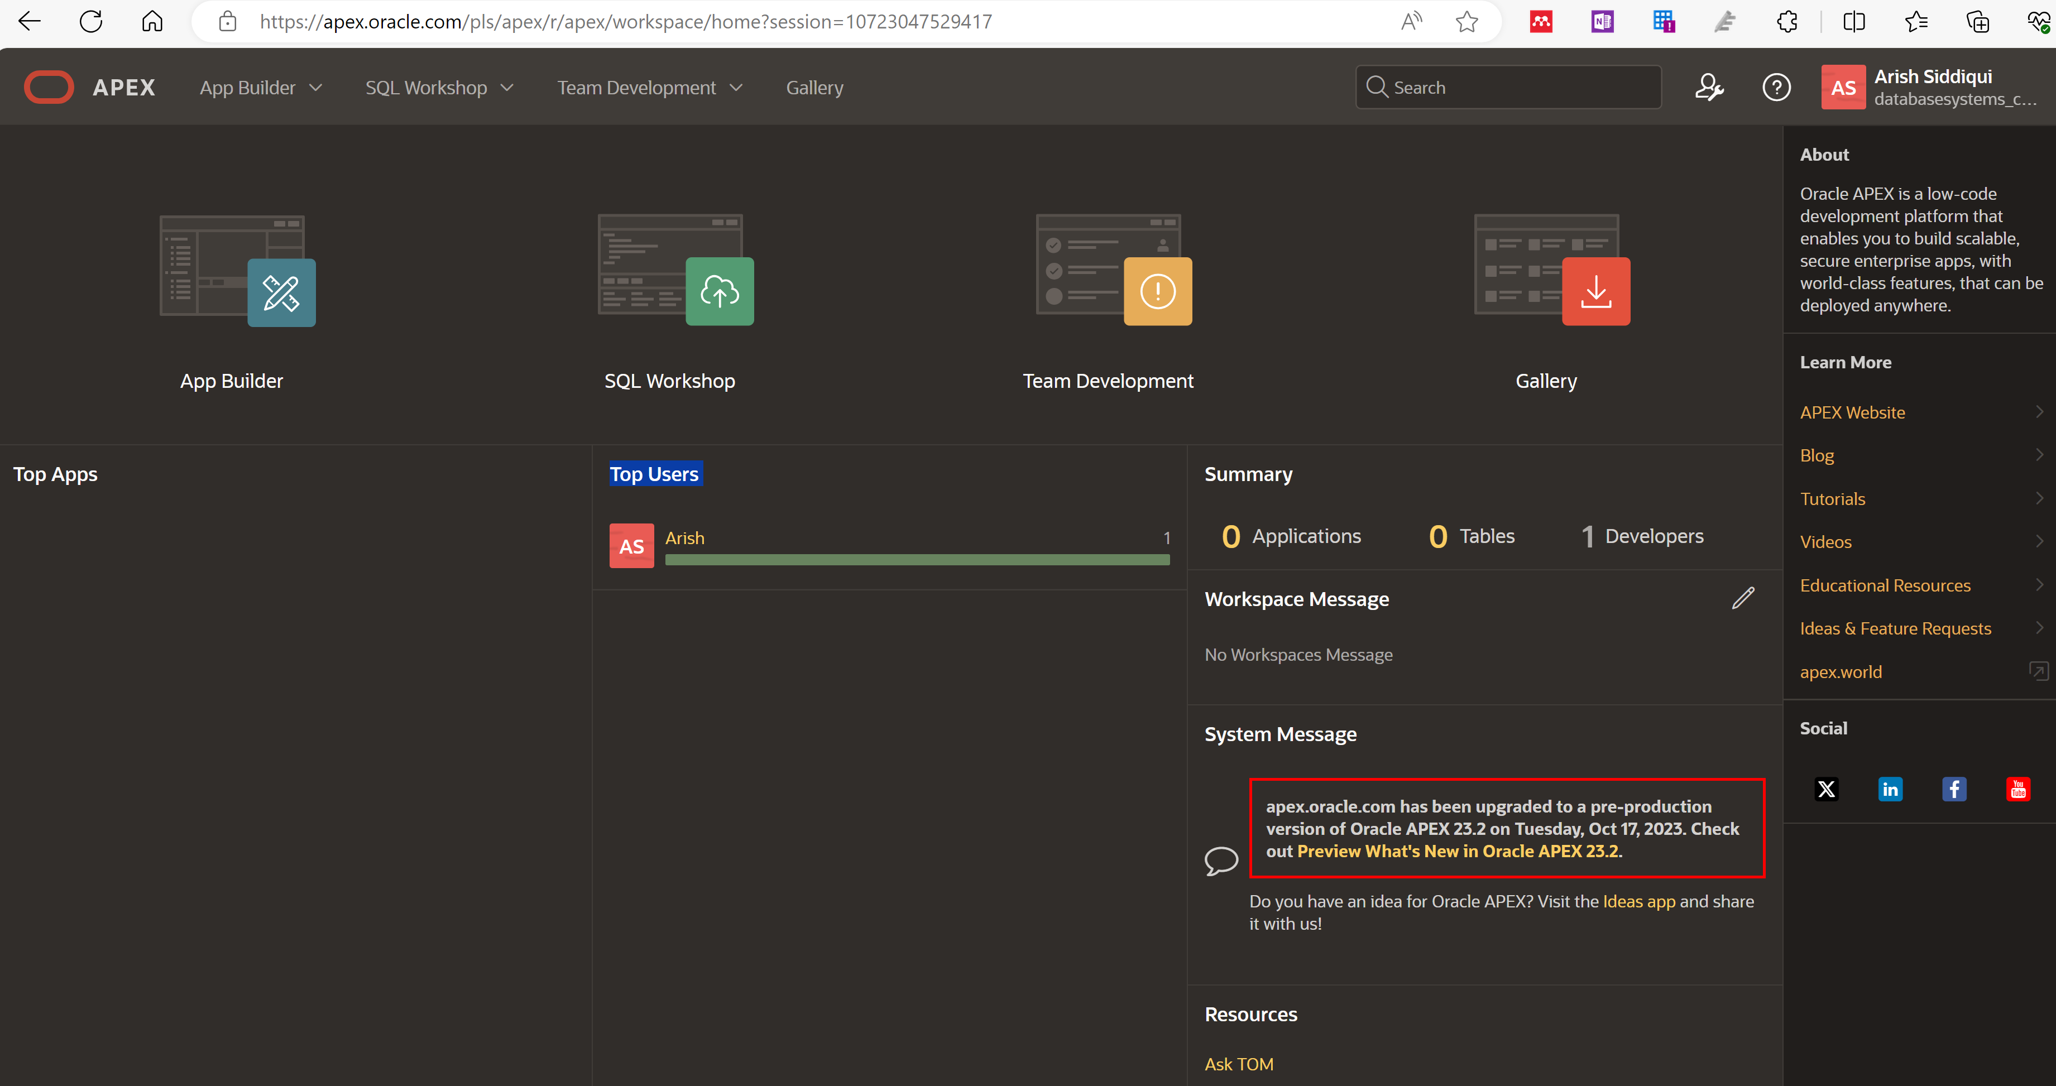

Congratulations! Apex is now ready to use.

**Next time login**: go to the below URL:

<https://apex.oracle.com/en/>

click on Sign in

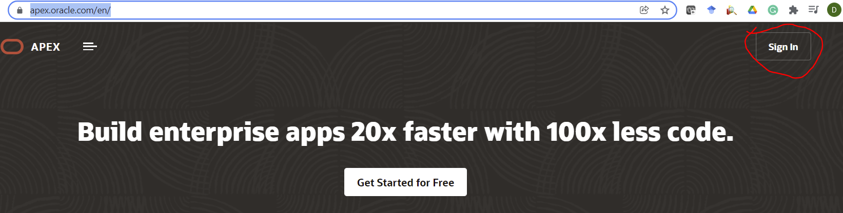

Provide the following to open the APEX workspace

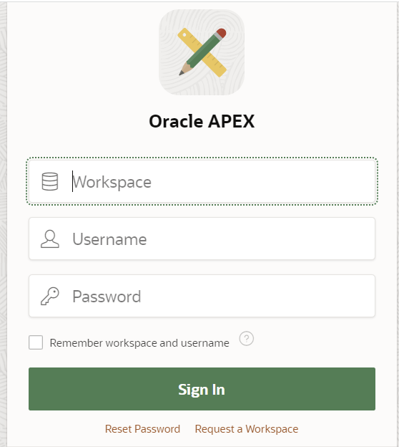

**Please do not discuss the MCQ in class they will be given as a QUIZ under consolidate.**

### **MCQ on Entity-Relationship Diagrams (ERD) and USE CASE**

1. **What does an Entity-Relationship Diagram primarily represent?**
   * A) System processes
   * B) Data relationships
   * C) User interactions
   * D) Software architecture
2. **In an ERD, what symbol is used to represent an entity?**
   * A) Oval
   * B) Rectangle
   * C) Diamond
   * D) Triangle
3. **What does a "crow's foot" notation represent in an ERD?**
   * A) Weak entity
   * B) Cardinality
   * C) Attribute
   * D) Relationship type
4. **Which of the following is NOT a type of relationship in an ERD?**
   * A) One-to-one
   * B) One-to-many
   * C) Many-to-many
   * D) Conditional
5. **What is an attribute in the context of an ERD?**
   * A) A unique identifier for an entity
   * B) A relationship between entities
   * C) A property of an entity
   * D) A type of entity
6. **What is the primary purpose of a Use Case Diagram?**
   * A) To represent the system architecture
   * B) To visualize user interactions with a system
   * C) To define database relationships
   * D) To outline project timelines
7. **In a Use Case Diagram, what does an actor represent?**
   * A) A user or another system that interacts with the system
   * B) A specific use case
   * C) A system component
   * D) A data storage element
8. **What notation is used to represent a use case in a Use Case Diagram?**
   * A) Rectangle
   * B) Circle
   * C) Oval
   * D) Diamond
9. **Which of the following best describes the relationship between an actor and a use case?**
   * A) Generalization
   * B) Association
   * C) Dependency
   * D) Aggregation
10. **What does the <<extend>> relationship signify in a Use Case Diagram?**
    * A) Mandatory behavior in a use case
    * B) Optional behavior that enhances a use case
    * C) A generalization of use cases
    * D) A direct dependency between use cases